John Deere Davenport Works

Background

The John Deere Davenport Works is a medium sized factory in the Construction and Forestry Division of Deere and Company. This project focuses on the cab operation in the factory. A cab is the operator’s enclosure with glass, doors, seat, steering wheel, dash, controls, electrical system, heating and air conditioning system, lights etc. For construction products the cab is a self-contained unit, which is assembled separately and mounted on the machine later at the time of vehicle assembly. The cab operation currently produces cabs for 3 construction equipment products (loaders, skidders, and backhoes) and intends to produce cabs for an additional 3 products (graders, utility crawlers, and construction crawlers) in the near future.

All of the material utilized in cab assembly is delivered by semi-trailers. Certain finished cabs are also shipped out by semi-trailer. Other finished cabs are delivered to vehicle assembly lines within the Davenport Works. Raw material and finished goods flow at full production will generate about 60 semi-trailer loads of material per day.

Problem

The cab operation is housed in a long narrow building that was originally built for other purposes. The 6 semi-trailer docks are on one end of the building rather than centrally located. Material is moved from the semi-trailer docks to assembly lines by fork trucks. Henceforth this operation will be referred to as trucking (note that the term trucking does not refer to moving material in semi-trailers external to the building). One-way trucking distance ranges from 100 feet for assembly lines located close to the semi-trailer docks, to nearly 1000 feet for assembly lines at the other end of the building. Since each cab assembled represents several fork truck trips, a substantial amount of time is consumed moving material.

Backhoe cabs are outside the scope of this analysis. Backhoe cabs are excluded because that assembly line is located right next the existing docks and it does not make sense to utilize any other dock locations. The production of backhoe cabs utilizes 3 of the 6 loading docks, leaving 3 docks available for other products.

Based on anticipated production schedules for current (loaders, skidders and backhoes) and new (graders and crawlers) products, it has been determined that the current loading dock capacity will not be adequate to handle the trucking of cabs within the factory. The problem is to determine the least expensive way to augment this capacity.

Alternatives

Alternative #1: Add docks

One or more loading docks could be added at a central location along the west wall of the building. For some production lines the trucking distance to these docks would be substantially less than the distance to the current docks at the end of the building. The construction of each dock requires a capital expense of $70,000.

Alternative #2: Utilize soft-side trailers

Soft-side trailers have fabric sides that pull back to allow direct fork truck access to the load without requiring a dock. Soft-side trailers can be brought into the cab assembly building and located near an assembly line. The benefit of soft-side trailers is that they increase the material handling capacity of the cab operation with no capital investment. However soft-side trailers consume significant useful factory floor space, can be difficult to maneuver inside the building and track in snow and dirt, especially in the winter months. The additional capacity provided by a soft-side trailer is also much less than that of a dock, due to the fact that it takes much longer to exchange soft-side trailers inside the factory than it does to exchange semi trailers at a dock.

Note that additional docks and soft-side trailers are not mutually exclusive - they could also be used in combination. Operations managers feel strongly that new dock(s) are a superior solution to the use of soft-side trailers. However, since new dock(s) require capital outlay there must be a demonstrated financial savings associated with their use. Senior management at Deere typically uses a 10-year NPV to evaluate capital expenditures of this type. The current discount rate for NPV computation is 6% per year.

Data

Data consists of forecasted production quantities, trucking requirements for different products, trucking distances between assembly lines and dock/soft-side locations, and financial assumptions.

Trucking Requirements

Anticipated annual production quantities (cabs/yr) and trucking requirements (fork truck loads/cab) are given in the Table 1.

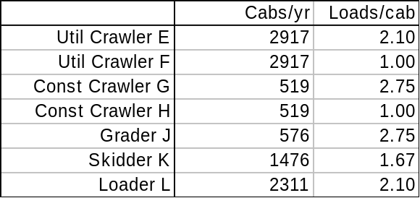
Table 1.

For crawlers, requirements are listed twice because trucking will occur for both raw materials at the start of the line and finished product at the end of the line. Loads are given in fractional form since parts can be combined to make up full fork truck loads.

Distances

Round-trip distances (in feet) between dock/soft-side and assembly line locations are given in Table 2. There are 2 potential locations (C and D) for soft-side trailers; a maximum of one trailer could be cited at each of these locations. Round-trip distance is used because fork trucks generally run empty on their return trip.

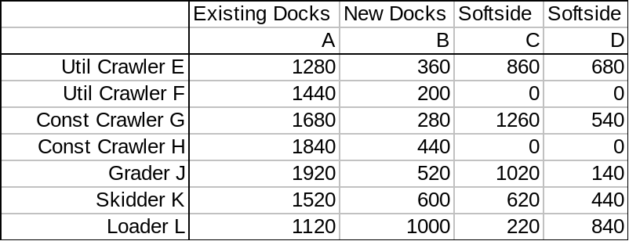
Table 2.

Costs and Capacities

Data on dock/soft-side fork truck capacity, and cost information, is given in Table 3.

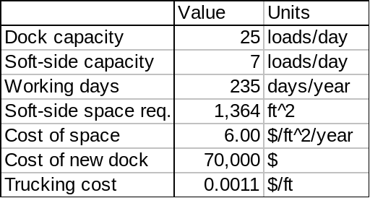
Table 3.

Trucking cost is based on actual data including both operator and equipment costs (depreciation and maintenance). Space cost is based on the cost for comparable industrial space and the assumption that the facility will be fully utilized.

Assignment

Determine a least-cost solution (using the 10-year NPV criterion) to the problem of expanding trucking capacity at the Davenport Works facility. Cost includes capital expense for dock construction, space cost for soft-side trailer(s), and trucking cost. The data in Tables 1, 2 and 3 is available in a spreadsheet on the course web site. Write a memo (10 pages max) describing your analysis and recommendations.

Written by Duane Eaton, David Gregor, Joel Slaby and Greg Snakenberg. Revised by Kurt Anstreicher, September 2004.

